**OLD**

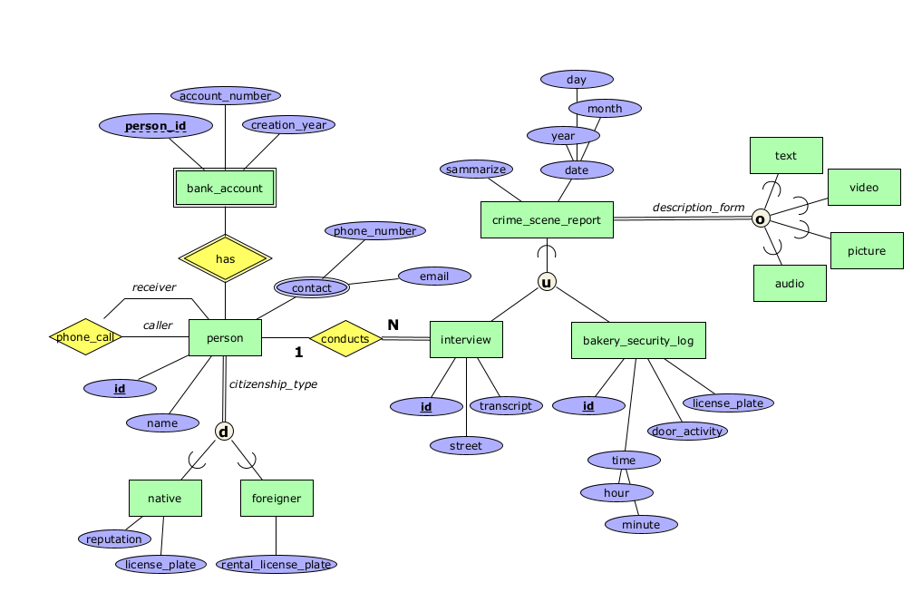

**NEW**

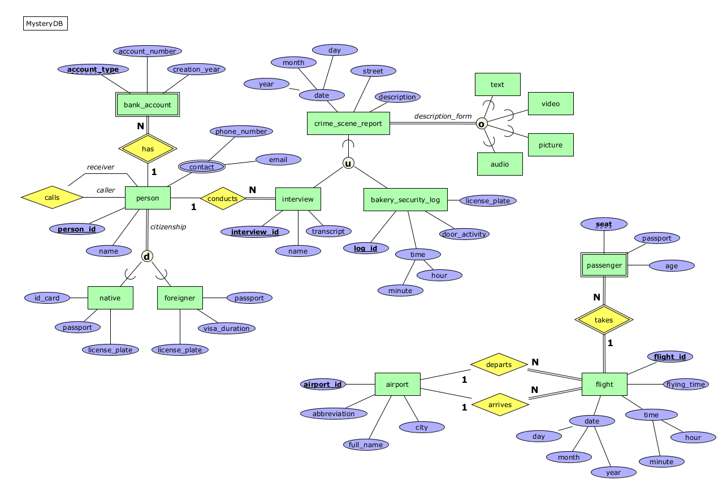

*Change attribute names:*

* person
  1. id → person_id
  2. citizenship_type → citizenship
* crime_scene_report
  1. sammarize → description
* foreigner
  1. Rental_licence_plate → licence_plate
* interview
  1. street → name
  2. id → interview_id
* bakery_security_log
  1. id → log_id

(Simplified naming, easier to understand and read)

*Change attribute:*

* person
  1. phone_call → call (rethink Recursive and change it to a relationship that can be implemented in RDB)
* bank_account
  1. partial key change to account_type (for each person, the account type is unique, and the primary key of the person combined with the account type can identify the bank_account)
* crime_scene_report
  1. + street (Increased to 3 attributes)
* native (Increased to 3 attributes)
  1. + id_card
  2. + passport
  3. – reputation
* foreigner (Increased to 3 attributes)
  1. + passport
  2. + visa_duration

*Additional relation:*

* airport
* flight
* passenger

*Description:*

1. Each person can conduct multiple interviews, and every interview must be conducted by someone.
2. Each person can have multiple accounts, and each account must be owned by someone.
3. The call records who the last call was.
4. Each person must be a native or a foreigner.
5. Each crime_scene_report must contain a record form, multiple selections are allowed.
6. All flights must depart from and arrive at one of the airports.
7. Every flight must have at least one passenger, and all passengers must have a flight on board.